SCHOOL OF MEDICINE  
*UC Davis Emeriti Association Survey*  
**March 23rd 2025, 3:51 pm MDT**

**Q4 - Name:**

**Q8 - What is your preferred method for being contacted to keep you informed of events or programs in your School or College, the UCD Emeriti Association or the Campus? Please rank your choices by dragging the options to the top or bottom.**

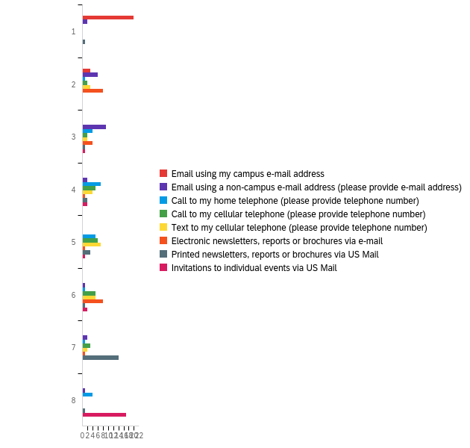

|  |  |  |  |  |  |  |  |
| --- | --- | --- | --- | --- | --- | --- | --- |
| # | Field | Minimum | Maximum | Mean | Std Deviation | Variance | Count |
| 1 | Email using my campus e-mail address | 1.00 | 2.00 | 1.13 | 0.34 | 0.11 | 23 |
| 2 | Email using a non-campus e-mail address (please provide e-mail address) | 1.00 | 8.00 | 3.35 | 1.86 | 3.44 | 23 |
| 3 | Call to my home telephone (please provide telephone number) | 2.00 | 8.00 | 4.87 | 1.78 | 3.16 | 23 |
| 4 | Call to my cellular telephone (please provide telephone number) | 2.00 | 7.00 | 4.83 | 1.43 | 2.06 | 23 |
| 5 | Text to my cellular telephone (please provide telephone number) | 2.00 | 7.00 | 4.65 | 1.46 | 2.14 | 23 |
| 6 | Electronic newsletters, reports or brochures via e-mail | 2.00 | 7.00 | 4.00 | 1.84 | 3.39 | 23 |
| 7 | Printed newsletters, reports or brochures via US Mail | 1.00 | 8.00 | 6.04 | 1.65 | 2.74 | 23 |
| 8 | Invitations to individual events via US Mail | 3.00 | 8.00 | 7.13 | 1.57 | 2.46 | 23 |

|  |  |  |  |  |  |  |  |  |  |  |  |  |  |  |  |  |  |  |
| --- | --- | --- | --- | --- | --- | --- | --- | --- | --- | --- | --- | --- | --- | --- | --- | --- | --- | --- |
| # | Question | 1 |  | 2 |  | 3 |  | 4 |  | 5 |  | 6 |  | 7 |  | 8 |  | Total |
| 1 | Email using my campus e-mail address | 86.96% | 20 | 13.04% | 3 | 0.00% | 0 | 0.00% | 0 | 0.00% | 0 | 0.00% | 0 | 0.00% | 0 | 0.00% | 0 | 23 |
| 2 | Email using a non-campus e-mail address (please provide e-mail address) | 8.70% | 2 | 26.09% | 6 | 39.13% | 9 | 8.70% | 2 | 0.00% | 0 | 4.35% | 1 | 8.70% | 2 | 4.35% | 1 | 23 |
| 3 | Call to my home telephone (please provide telephone number) | 0.00% | 0 | 4.35% | 1 | 17.39% | 4 | 30.43% | 7 | 21.74% | 5 | 4.35% | 1 | 4.35% | 1 | 17.39% | 4 | 23 |
| 4 | Call to my cellular telephone (please provide telephone number) | 0.00% | 0 | 8.70% | 2 | 8.70% | 2 | 21.74% | 5 | 26.09% | 6 | 21.74% | 5 | 13.04% | 3 | 0.00% | 0 | 23 |
| 5 | Text to my cellular telephone (please provide telephone number) | 0.00% | 0 | 13.04% | 3 | 8.70% | 2 | 17.39% | 4 | 30.43% | 7 | 21.74% | 5 | 8.70% | 2 | 0.00% | 0 | 23 |
| 6 | Electronic newsletters, reports or brochures via e-mail | 0.00% | 0 | 34.78% | 8 | 17.39% | 4 | 4.35% | 1 | 4.35% | 1 | 34.78% | 8 | 4.35% | 1 | 0.00% | 0 | 23 |
| 7 | Printed newsletters, reports or brochures via US Mail | 4.35% | 1 | 0.00% | 0 | 4.35% | 1 | 8.70% | 2 | 13.04% | 3 | 4.35% | 1 | 60.87% | 14 | 4.35% | 1 | 23 |
| 8 | Invitations to individual events via US Mail | 0.00% | 0 | 0.00% | 0 | 4.35% | 1 | 8.70% | 2 | 4.35% | 1 | 8.70% | 2 | 0.00% | 0 | 73.91% | 17 | 23 |

**Q9 - Your School, College or Unit at the time of retirement:**

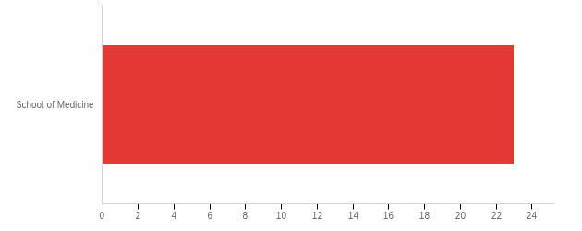

|  |  |  |  |  |  |  |  |
| --- | --- | --- | --- | --- | --- | --- | --- |
| # | Field | Minimum | Maximum | Mean | Std Deviation | Variance | Count |
| 1 | Your School, College or Unit at the time of retirement: - Selected Choice | 10.00 | 10.00 | 10.00 | 0.00 | 0.00 | 23 |

|  |  |  |  |
| --- | --- | --- | --- |
| # | Answer | % | Count |
| 10 | School of Medicine | 100.00% | 23 |
|  | Total | 100% | 23 |

Q9_16_TEXT - Other  
Other - Text

**Q10 - Your Department at the time of retirement:**

|  |
| --- |
| Your Department at the time of retirement: |
| Physiology & Membrane Biology |
| Internal Medicine |
| Pediatrics |
| Neurological Surgery |
| Internal Medicine |
| Psychiatry |
| Family and Community Medicine |
| Internal Medicine |
| Physiology and Membrane Biology |
| Cell Biology and Human Anatomy |
| Internal med: nephrology |
| Surgery |
| Internal Medicine, Division of Infectious Diseases |
| Neurological Surgery |
| Psychiatry |
| Internal Medicine AND Physiology and Membrane Physiology |
| Pathology & Laboratory Medicine |
| Orthopaedics |
| Pathology and Laboratory Medicine |
| Psychiatry and Behavioral Sciences |
| Anesthesiology & Pain Medicine |
| internal medicine |
| x |

**Q11 - If you held an appointment in more than one School, College, Unit or Department during your tenure at UC Davis, please specify here:**

|  |
| --- |
| If you held an appointment in more than one School, College, Unit or Department during your tenure at UC Davis, please specify here: |
| SOM:Pharmacology; CBS: NPB |
| Hyman Physiology Dept., Sch Med |
| Graduate School (Epidemiology), Internal Medicine |
| Department of Medical Microbiology and Immunology |
| member of two departments as indicated |
| Surgery, Plastic Surgery Division |
| x |

**Q12 - Year you were hired as a faculty member at UC Davis:**

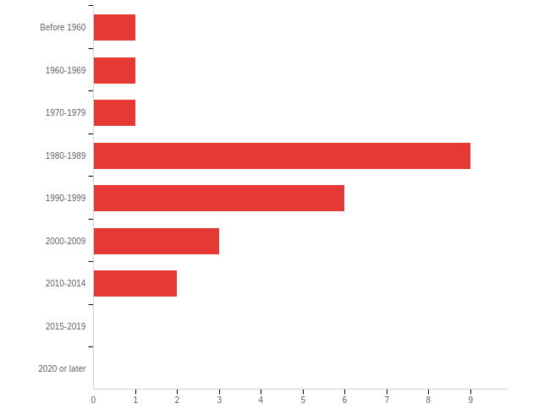

|  |  |  |  |  |  |  |  |
| --- | --- | --- | --- | --- | --- | --- | --- |
| # | Field | Minimum | Maximum | Mean | Std Deviation | Variance | Count |
| 1 | Year you were hired as a faculty member at UC Davis: | 1.00 | 7.00 | 4.52 | 1.38 | 1.90 | 23 |

|  |  |  |  |
| --- | --- | --- | --- |
| # | Answer | % | Count |
| 1 | Before 1960 | 4.35% | 1 |
| 2 | 1960-1969 | 4.35% | 1 |
| 3 | 1970-1979 | 4.35% | 1 |
| 4 | 1980-1989 | 39.13% | 9 |
| 5 | 1990-1999 | 26.09% | 6 |
| 6 | 2000-2009 | 13.04% | 3 |
| 7 | 2010-2014 | 8.70% | 2 |
| 8 | 2015-2019 | 0.00% | 0 |
| 9 | 2020 or later | 0.00% | 0 |
|  | Total | 100% | 23 |

**Q13 - Year you retired from the faculty at UC Davis:**

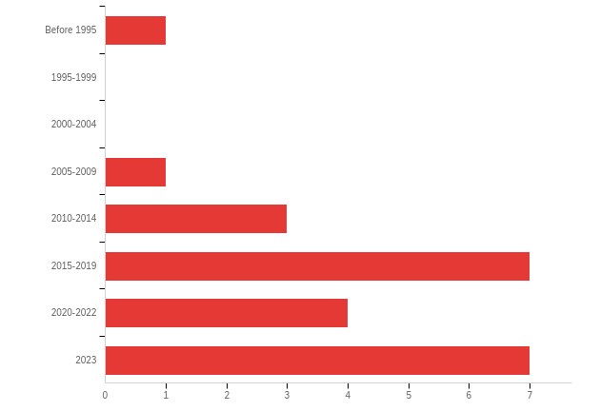

|  |  |  |  |  |  |  |  |
| --- | --- | --- | --- | --- | --- | --- | --- |
| # | Field | Minimum | Maximum | Mean | Std Deviation | Variance | Count |
| 1 | Year you retired from the faculty at UC Davis: | 1.00 | 8.00 | 6.35 | 1.63 | 2.66 | 23 |

|  |  |  |  |
| --- | --- | --- | --- |
| # | Answer | % | Count |
| 1 | Before 1995 | 4.35% | 1 |
| 2 | 1995-1999 | 0.00% | 0 |
| 3 | 2000-2004 | 0.00% | 0 |
| 4 | 2005-2009 | 4.35% | 1 |
| 5 | 2010-2014 | 13.04% | 3 |
| 6 | 2015-2019 | 30.43% | 7 |
| 7 | 2020-2022 | 17.39% | 4 |
| 8 | 2023 | 30.43% | 7 |
|  | Total | 100% | 23 |

**Q14 - Number of years of service to UC at the time of retirement?**

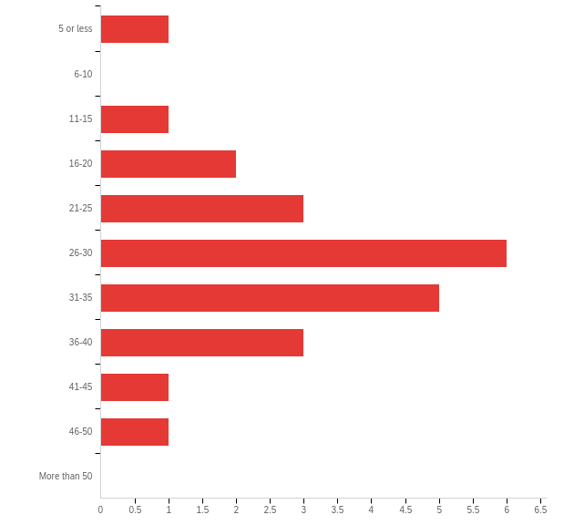

|  |  |  |  |  |  |  |  |
| --- | --- | --- | --- | --- | --- | --- | --- |
| # | Field | Minimum | Maximum | Mean | Std Deviation | Variance | Count |
| 1 | Number of years of service to UC at the time of retirement? | 1.00 | 10.00 | 6.13 | 1.94 | 3.77 | 23 |

|  |  |  |  |
| --- | --- | --- | --- |
| # | Answer | % | Count |
| 1 | 5 or less | 4.35% | 1 |
| 2 | 6-10 | 0.00% | 0 |
| 3 | 11-15 | 4.35% | 1 |
| 4 | 16-20 | 8.70% | 2 |
| 5 | 21-25 | 13.04% | 3 |
| 6 | 26-30 | 26.09% | 6 |
| 7 | 31-35 | 21.74% | 5 |
| 8 | 36-40 | 13.04% | 3 |
| 9 | 41-45 | 4.35% | 1 |
| 10 | 46-50 | 4.35% | 1 |
| 11 | More than 50 | 0.00% | 0 |
|  | Total | 100% | 23 |

**Q15 - If you retired more than once, as is the case for faculty who were rehired after retiring, please indicate all the years during which you retired.**

|  |
| --- |
| If you retired more than once, as is the case for faculty who were rehired after retiring, please indicate all the years during which you retired. |
| 2020-2023 |
| still in rehired years grant funded |

**Q17 - Around the time of your retirement, did a representative of your Department or School/College ask you if you wanted to continue to participate in University-related activities in retirement?**

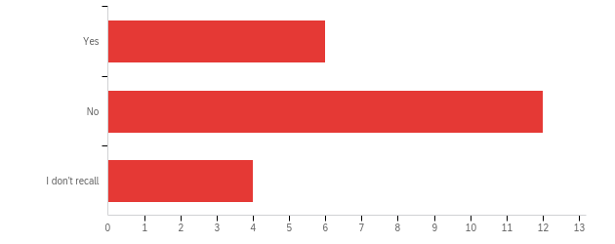

|  |  |  |  |  |  |  |  |
| --- | --- | --- | --- | --- | --- | --- | --- |
| # | Field | Minimum | Maximum | Mean | Std Deviation | Variance | Count |
| 1 | Around the time of your retirement, did a representative of your Department or School/College ask you if you wanted to continue to participate in University-related activities in retirement? | 1.00 | 3.00 | 1.91 | 0.67 | 0.45 | 22 |

|  |  |  |  |
| --- | --- | --- | --- |
| # | Answer | % | Count |
| 1 | Yes | 27.27% | 6 |
| 2 | No | 54.55% | 12 |
| 3 | I don't recall | 18.18% | 4 |
|  | Total | 100% | 22 |

**Q18 - If you have been retired for less than one year, to what extent do you anticipate being involved in the activities of your Department, School/College or Campus in retirement?**

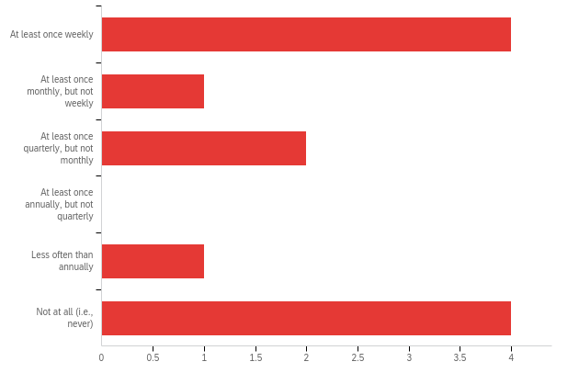

|  |  |  |  |  |  |  |  |
| --- | --- | --- | --- | --- | --- | --- | --- |
| # | Field | Minimum | Maximum | Mean | Std Deviation | Variance | Count |
| 1 | If you have been retired for less than one year, to what extent do you anticipate being involved in the activities of your Department, School/College or Campus in retirement? | 1.00 | 6.00 | 3.42 | 2.14 | 4.58 | 12 |

|  |  |  |  |
| --- | --- | --- | --- |
| # | Answer | % | Count |
| 1 | At least once weekly | 33.33% | 4 |
| 2 | At least once monthly, but not weekly | 8.33% | 1 |
| 3 | At least once quarterly, but not monthly | 16.67% | 2 |
| 4 | At least once annually, but not quarterly | 0.00% | 0 |
| 5 | Less often than annually | 8.33% | 1 |
| 6 | Not at all (i.e., never) | 33.33% | 4 |
|  | Total | 100% | 12 |

**Q19 - Have you been formally recalled since your retirement to provide services to your Department, School or College?**

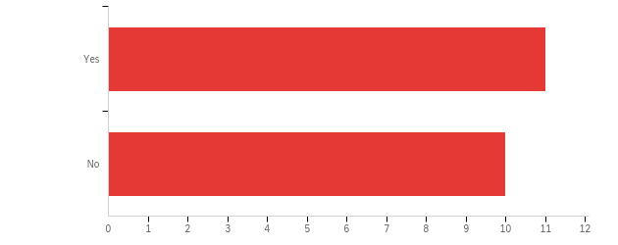

|  |  |  |  |  |  |  |  |
| --- | --- | --- | --- | --- | --- | --- | --- |
| # | Field | Minimum | Maximum | Mean | Std Deviation | Variance | Count |
| 1 | Have you been formally recalled since your retirement to provide services to your Department, School or College? | 1.00 | 2.00 | 1.48 | 0.50 | 0.25 | 21 |

|  |  |  |  |
| --- | --- | --- | --- |
| # | Answer | % | Count |
| 1 | Yes | 52.38% | 11 |
| 2 | No | 47.62% | 10 |
|  | Total | 100% | 21 |

**Q20 - In which of the following Department, School/College or Campus activities have you been engaged since your retirement? Please check all that apply.**

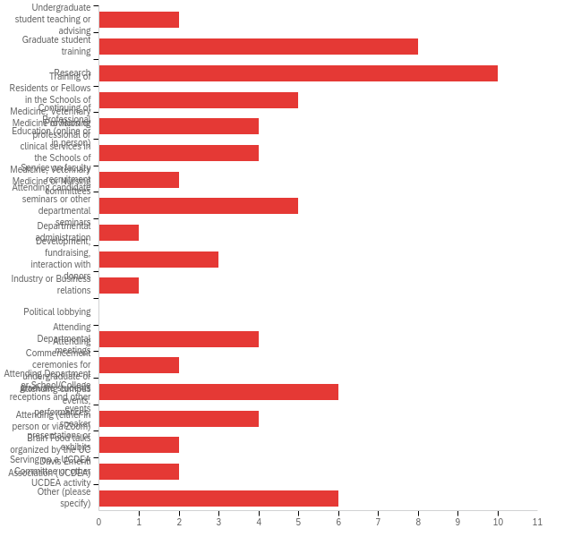

|  |  |  |  |
| --- | --- | --- | --- |
| # | Answer | % | Count |
| 1 | Undergraduate student teaching or advising | 2.82% | 2 |
| 2 | Graduate student training | 11.27% | 8 |
| 3 | Research | 14.08% | 10 |
| 4 | Training of Residents or Fellows in the Schools of Medicine, Veterinary Medicine or Nursing | 7.04% | 5 |
| 5 | Continuing of Professional Education (online or in person) | 5.63% | 4 |
| 6 | Provision or professional or clinical services in the Schools of Medicine, Veterinary Medicine or Nursing | 5.63% | 4 |
| 7 | Service on faculty recruitment committees | 2.82% | 2 |
| 8 | Attending candidate seminars or other departmental seminars | 7.04% | 5 |
| 9 | Departmental administration | 1.41% | 1 |
| 10 | Development, fundraising, interaction with donors | 4.23% | 3 |
| 11 | Industry or Business relations | 1.41% | 1 |
| 12 | Political lobbying | 0.00% | 0 |
| 13 | Attending Departmental meetings | 5.63% | 4 |
| 14 | Attending Commencement ceremonies for undergraduate or graduate students | 2.82% | 2 |
| 15 | Attending Department or School/College receptions and other events | 8.45% | 6 |
| 16 | Attending campus events, performances, speaker presentations or exhibits | 5.63% | 4 |
| 17 | Attending (either in person or via Zoom) Brain Food talks organized by the UC Davis Emeriti Association (UCDEA) | 2.82% | 2 |
| 18 | Serving on a UCDEA Committee or other UCDEA activity | 2.82% | 2 |
| 19 | Other (please specify) | 8.45% | 6 |
|  | Total | 100% | 71 |

Q20_19_TEXT - Other (please specify)

|  |
| --- |
| Other (please specify) - Text |
| Research collaboration with group at Mt Sinai Med Ctr in NY and using my UCD affiliation identifier in the publications. |
| Graduate Group Chair |
| Directing environmental sustainability efforts in the Health System, coordinating the docent program at Stebbins Cold Canyon Reserve, trail maintenance at Stebbins Cold Canyon Reserve and Quail Ridge Reserve |
| Participate as an instructor in leadership development programs |
| None |

**Q21 - In which of the following Department, School/College or Campus activities would you like to participate in the future? Please check all that apply.**

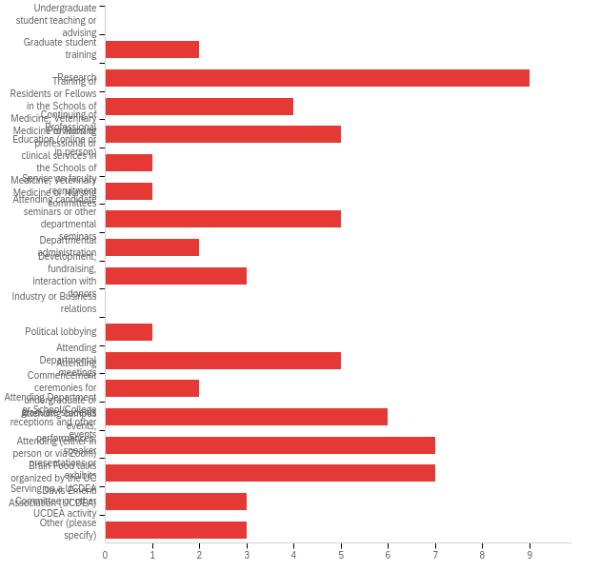

|  |  |  |  |
| --- | --- | --- | --- |
| # | Answer | % | Count |
| 1 | Undergraduate student teaching or advising | 0.00% | 0 |
| 2 | Graduate student training | 3.03% | 2 |
| 3 | Research | 13.64% | 9 |
| 4 | Training of Residents or Fellows in the Schools of Medicine, Veterinary Medicine or Nursing | 6.06% | 4 |
| 5 | Continuing of Professional Education (online or in person) | 7.58% | 5 |
| 6 | Provision or professional or clinical services in the Schools of Medicine, Veterinary Medicine or Nursing | 1.52% | 1 |
| 7 | Service on faculty recruitment committees | 1.52% | 1 |
| 8 | Attending candidate seminars or other departmental seminars | 7.58% | 5 |
| 9 | Departmental administration | 3.03% | 2 |
| 10 | Development, fundraising, interaction with donors | 4.55% | 3 |
| 11 | Industry or Business relations | 0.00% | 0 |
| 12 | Political lobbying | 1.52% | 1 |
| 13 | Attending Departmental meetings | 7.58% | 5 |
| 14 | Attending Commencement ceremonies for undergraduate or graduate students | 3.03% | 2 |
| 15 | Attending Department or School/College receptions and other events | 9.09% | 6 |
| 16 | Attending campus events, performances, speaker presentations or exhibits | 10.61% | 7 |
| 17 | Attending (either in person or via Zoom) Brain Food talks organized by the UC Davis Emeriti Association (UCDEA) | 10.61% | 7 |
| 18 | Serving on a UCDEA Committee or other UCDEA activity | 4.55% | 3 |
| 19 | Other (please specify) | 4.55% | 3 |
|  | Total | 100% | 66 |

Q21_19_TEXT - Other (please specify)

|  |
| --- |
| Other (please specify) - Text |
| Participation in an IRB |
| Sustainability work at UCDH, volunteering at the NRS |
| prefer Sacramento based events |

**Q22 - How frequently are you currently involved in the activities of your Department, School/ College or Campus in retirement?**

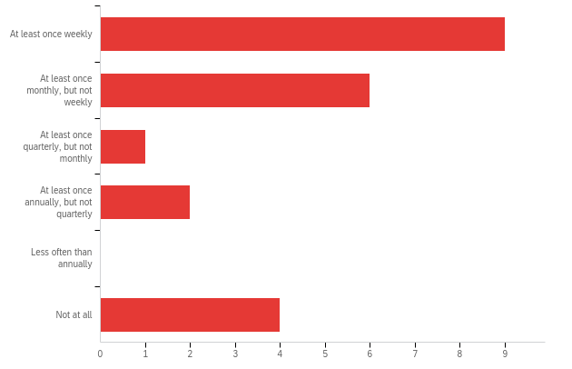

|  |  |  |  |  |  |  |  |
| --- | --- | --- | --- | --- | --- | --- | --- |
| # | Field | Minimum | Maximum | Mean | Std Deviation | Variance | Count |
| 1 | How frequently are you currently involved in the activities of your Department, School/ College or Campus in retirement? | 1.00 | 6.00 | 2.55 | 1.85 | 3.43 | 22 |

|  |  |  |  |
| --- | --- | --- | --- |
| # | Answer | % | Count |
| 1 | At least once weekly | 40.91% | 9 |
| 2 | At least once monthly, but not weekly | 27.27% | 6 |
| 3 | At least once quarterly, but not monthly | 4.55% | 1 |
| 4 | At least once annually, but not quarterly | 9.09% | 2 |
| 5 | Less often than annually | 0.00% | 0 |
| 6 | Not at all | 18.18% | 4 |
|  | Total | 100% | 22 |

**Q24 - If you have been retired for five years or more, how frequently were you involved in the activities of your Department, School/College or Campus during the first five years after retirement?**

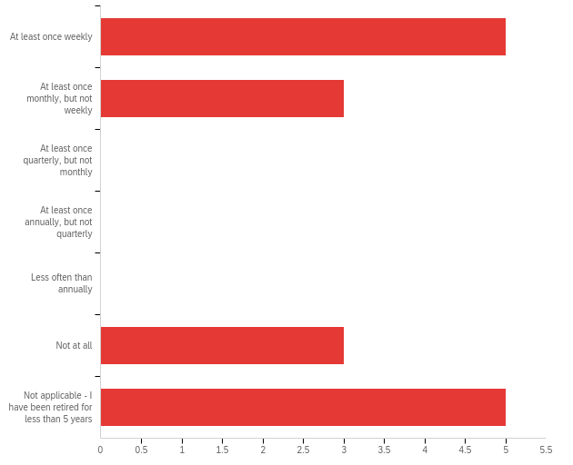

|  |  |  |  |  |  |  |  |
| --- | --- | --- | --- | --- | --- | --- | --- |
| # | Field | Minimum | Maximum | Mean | Std Deviation | Variance | Count |
| 1 | If you have been retired for five years or more, how frequently were you involved in the activities of your Department, School/College or Campus during the first five years after retirement? | 1.00 | 7.00 | 4.00 | 2.67 | 7.13 | 16 |

|  |  |  |  |
| --- | --- | --- | --- |
| # | Answer | % | Count |
| 1 | At least once weekly | 31.25% | 5 |
| 2 | At least once monthly, but not weekly | 18.75% | 3 |
| 3 | At least once quarterly, but not monthly | 0.00% | 0 |
| 4 | At least once annually, but not quarterly | 0.00% | 0 |
| 5 | Less often than annually | 0.00% | 0 |
| 6 | Not at all | 18.75% | 3 |
| 7 | Not applicable - I have been retired for less than 5 years | 31.25% | 5 |
|  | Total | 100% | 16 |

**Q25 - How many events, such as Commencement ceremonies, performances, exhibits, visiting speakers, Department or School/College receptions, or Picnic Day did you attend on campus during 2023?**

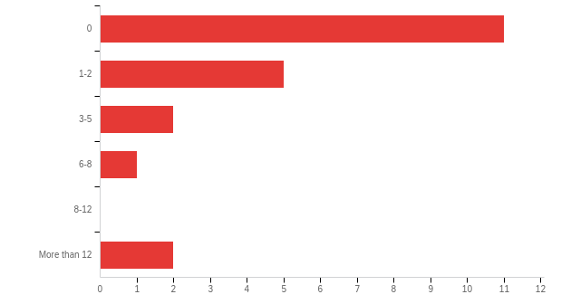

|  |  |  |  |  |  |  |  |
| --- | --- | --- | --- | --- | --- | --- | --- |
| # | Field | Minimum | Maximum | Mean | Std Deviation | Variance | Count |
| 1 | How many events, such as Commencement ceremonies, performances, exhibits, visiting speakers, Department or School/College receptions, or Picnic Day did you attend on campus during 2023? | 1.00 | 6.00 | 2.05 | 1.53 | 2.33 | 21 |

|  |  |  |  |
| --- | --- | --- | --- |
| # | Answer | % | Count |
| 1 | 0 | 52.38% | 11 |
| 2 | 1-2 | 23.81% | 5 |
| 3 | 3-5 | 9.52% | 2 |
| 4 | 6-8 | 4.76% | 1 |
| 5 | 8-12 | 0.00% | 0 |
| 6 | More than 12 | 9.52% | 2 |
|  | Total | 100% | 21 |

**Q26 - If you no longer interact with your Department, School/College or the Campus, why not? Please check all that apply.**

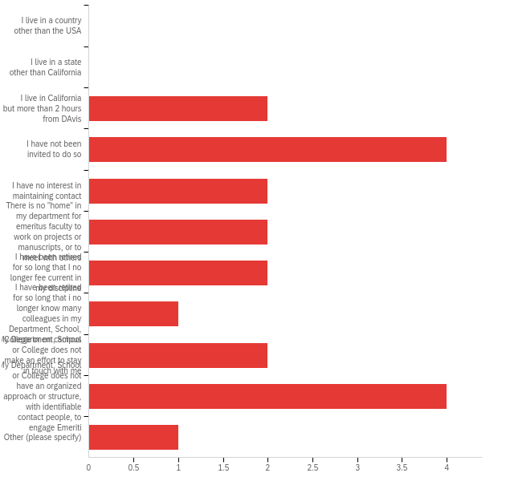

|  |  |  |  |
| --- | --- | --- | --- |
| # | Answer | % | Count |
| 1 | I live in a country other than the USA | 0.00% | 0 |
| 2 | I live in a state other than California | 0.00% | 0 |
| 3 | I live in California but more than 2 hours from DAvis | 10.00% | 2 |
| 4 | I have not been invited to do so | 20.00% | 4 |
| 5 | I have no interest in maintaining contact | 10.00% | 2 |
| 6 | There is no "home" in my department for emeritus faculty to work on projects or manuscripts, or to meet with others | 10.00% | 2 |
| 7 | I have been retired for so long that I no longer fee current in my discipline | 10.00% | 2 |
| 8 | I have been retired for so long that i no longer know many colleagues in my Department, School, College or on campus | 5.00% | 1 |
| 9 | My Department, School or College does not make an effort to stay in touch with me | 10.00% | 2 |
| 10 | My Department, School or College does not have an organized approach or structure, with identifiable contact people, to engage Emeriti | 20.00% | 4 |
| 11 | Other (please specify) | 5.00% | 1 |
|  | Total | 100% | 20 |

Q26_11_TEXT - Other (please specify)

|  |
| --- |
| Other (please specify) - Text |
| I don't know where else to write this but I think this survey is poorly designed at least because I was informed more than once by Barbara Horwitz that I was not faculty |

**Q28 - I have voting rights within my Department**

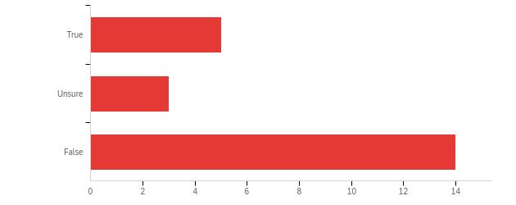

|  |  |  |  |  |  |  |  |
| --- | --- | --- | --- | --- | --- | --- | --- |
| # | Field | Minimum | Maximum | Mean | Std Deviation | Variance | Count |
| 1 | I have voting rights within my Department | 1.00 | 3.00 | 2.41 | 0.83 | 0.70 | 22 |

|  |  |  |  |
| --- | --- | --- | --- |
| # | Answer | % | Count |
| 1 | True | 22.73% | 5 |
| 2 | Unsure | 13.64% | 3 |
| 3 | False | 63.64% | 14 |
|  | Total | 100% | 22 |

**Q29 - My Department or School/College creates a welcoming environment for Emeriti and encourages them to remain active in the life of the School/College.**

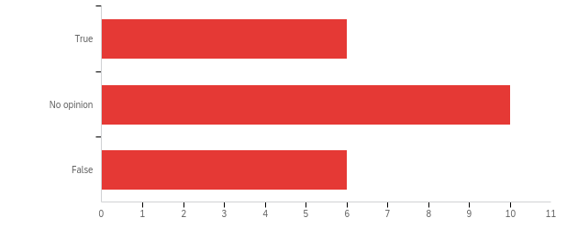

|  |  |  |  |  |  |  |  |
| --- | --- | --- | --- | --- | --- | --- | --- |
| # | Field | Minimum | Maximum | Mean | Std Deviation | Variance | Count |
| 1 | My Department or School/College creates a welcoming environment for Emeriti and encourages them to remain active in the life of the School/College. | 1.00 | 3.00 | 2.00 | 0.74 | 0.55 | 22 |

|  |  |  |  |
| --- | --- | --- | --- |
| # | Answer | % | Count |
| 1 | True | 27.27% | 6 |
| 2 | No opinion | 45.45% | 10 |
| 3 | False | 27.27% | 6 |
|  | Total | 100% | 22 |

**Q30 - My Department or School/College invites me to attend Commencement.**

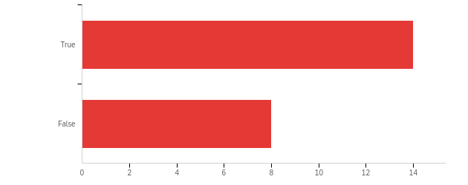

|  |  |  |  |  |  |  |  |
| --- | --- | --- | --- | --- | --- | --- | --- |
| # | Field | Minimum | Maximum | Mean | Std Deviation | Variance | Count |
| 1 | My Department or School/College invites me to attend Commencement. | 1.00 | 2.00 | 1.36 | 0.48 | 0.23 | 22 |

|  |  |  |  |
| --- | --- | --- | --- |
| # | Answer | % | Count |
| 1 | True | 63.64% | 14 |
| 2 | False | 36.36% | 8 |
|  | Total | 100% | 22 |

**Q31 - My Department or School/College invites me to attend at least one faculty reception annually.**



|  |  |  |  |  |  |  |  |
| --- | --- | --- | --- | --- | --- | --- | --- |
| # | Field | Minimum | Maximum | Mean | Std Deviation | Variance | Count |
| 1 | My Department or School/College invites me to attend at least one faculty reception annually. | 1.00 | 2.00 | 1.36 | 0.48 | 0.23 | 22 |

|  |  |  |  |
| --- | --- | --- | --- |
| # | Answer | % | Count |
| 1 | True | 63.64% | 14 |
| 2 | False | 36.36% | 8 |
|  | Total | 100% | 22 |

**Q32 - My Department or School/College adequately meets my needs for work and filing space for University-related business.**

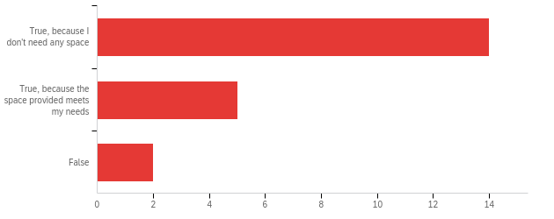

|  |  |  |  |  |  |  |  |
| --- | --- | --- | --- | --- | --- | --- | --- |
| # | Field | Minimum | Maximum | Mean | Std Deviation | Variance | Count |
| 1 | My Department or School/College adequately meets my needs for work and filing space for University-related business. | 1.00 | 3.00 | 1.43 | 0.66 | 0.44 | 21 |

|  |  |  |  |
| --- | --- | --- | --- |
| # | Answer | % | Count |
| 1 | True, because I don't need any space | 66.67% | 14 |
| 2 | True, because the space provided meets my needs | 23.81% | 5 |
| 3 | False | 9.52% | 2 |
|  | Total | 100% | 21 |

**Q33 - My Department or School/College provides space in which Emeriti can work or meet with colleagues or students.**

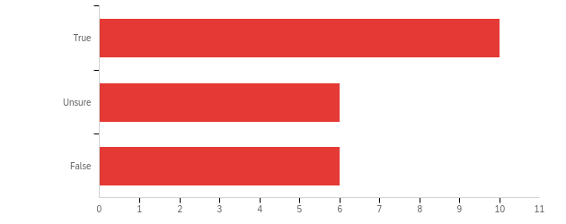

|  |  |  |  |  |  |  |  |
| --- | --- | --- | --- | --- | --- | --- | --- |
| # | Field | Minimum | Maximum | Mean | Std Deviation | Variance | Count |
| 1 | My Department or School/College provides space in which Emeriti can work or meet with colleagues or students. | 1.00 | 3.00 | 1.82 | 0.83 | 0.69 | 22 |

|  |  |  |  |
| --- | --- | --- | --- |
| # | Answer | % | Count |
| 1 | True | 45.45% | 10 |
| 2 | Unsure | 27.27% | 6 |
| 3 | False | 27.27% | 6 |
|  | Total | 100% | 22 |

**Q34 - If you answered "true" to the previous question, indicate which one of the following best describes the type of space provided to Emeriti who remain active in departmental programs:**

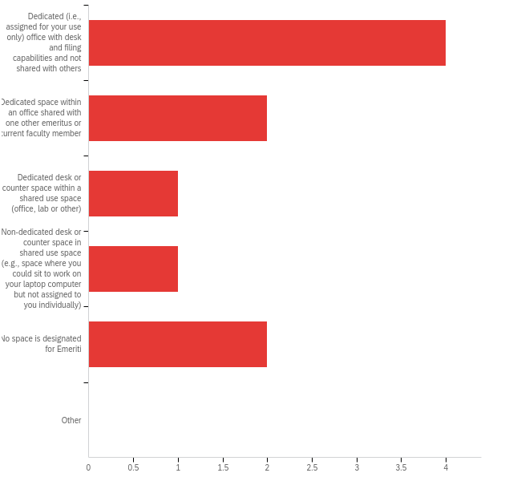

|  |  |  |  |  |  |  |  |
| --- | --- | --- | --- | --- | --- | --- | --- |
| # | Field | Minimum | Maximum | Mean | Std Deviation | Variance | Count |
| 1 | If you answered &quot;true&quot; to the previous question, indicate which one of the following best describes the type of space provided to Emeriti who remain active in departmental programs: | 1.00 | 5.00 | 2.50 | 1.57 | 2.45 | 10 |

|  |  |  |  |
| --- | --- | --- | --- |
| # | Answer | % | Count |
| 1 | Dedicated (i.e., assigned for your use only) office with desk and filing capabilities and not shared with others | 40.00% | 4 |
| 2 | Dedicated space within an office shared with one other emeritus or current faculty member | 20.00% | 2 |
| 3 | Dedicated desk or counter space within a shared use space (office, lab or other) | 10.00% | 1 |
| 4 | Non-dedicated desk or counter space in shared use space (e.g., space where you could sit to work on your laptop computer but not assigned to you individually) | 10.00% | 1 |
| 5 | No space is designated for Emeriti | 20.00% | 2 |
| 6 | Other | 0.00% | 0 |
|  | Total | 100% | 10 |

**Q35 - My Department or School/College adequately meets my facilities needs for University-related research.**

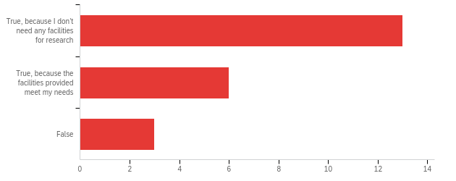

|  |  |  |  |  |  |  |  |
| --- | --- | --- | --- | --- | --- | --- | --- |
| # | Field | Minimum | Maximum | Mean | Std Deviation | Variance | Count |
| 1 | My Department or School/College adequately meets my facilities needs for University-related research. | 1.00 | 3.00 | 1.55 | 0.72 | 0.52 | 22 |

|  |  |  |  |
| --- | --- | --- | --- |
| # | Answer | % | Count |
| 1 | True, because I don’t need any facilities for research | 59.09% | 13 |
| 2 | True, because the facilities provided meet my needs | 27.27% | 6 |
| 3 | False | 13.64% | 3 |
|  | Total | 100% | 22 |

**Q36 - My Department or School/College adequately meets my needs for administrative support for University-related grant administration.**

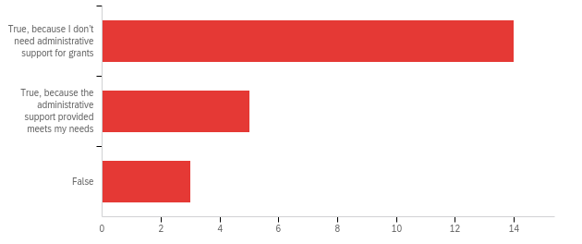

|  |  |  |  |  |  |  |  |
| --- | --- | --- | --- | --- | --- | --- | --- |
| # | Field | Minimum | Maximum | Mean | Std Deviation | Variance | Count |
| 1 | My Department or School/College adequately meets my needs for administrative support for University-related grant administration. | 1.00 | 3.00 | 1.50 | 0.72 | 0.52 | 22 |

|  |  |  |  |
| --- | --- | --- | --- |
| # | Answer | % | Count |
| 1 | True, because I don’t need administrative support for grants | 63.64% | 14 |
| 2 | True, because the administrative support provided meets my needs | 22.73% | 5 |
| 3 | False | 13.64% | 3 |
|  | Total | 100% | 22 |

**Q37 - My Department or School/College adequately meets my needs for IT and computer support for University-related business.**

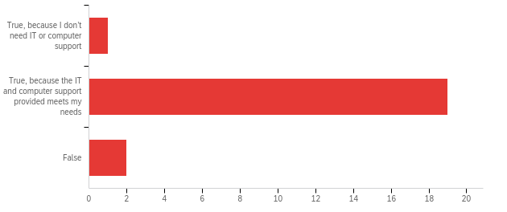

|  |  |  |  |  |  |  |  |
| --- | --- | --- | --- | --- | --- | --- | --- |
| # | Field | Minimum | Maximum | Mean | Std Deviation | Variance | Count |
| 1 | My Department or School/College adequately meets my needs for IT and computer support for University-related business. | 1.00 | 3.00 | 2.05 | 0.37 | 0.13 | 22 |

|  |  |  |  |
| --- | --- | --- | --- |
| # | Answer | % | Count |
| 1 | True, because I don’t need IT or computer support | 4.55% | 1 |
| 2 | True, because the IT and computer support provided meets my needs | 86.36% | 19 |
| 3 | False | 9.09% | 2 |
|  | Total | 100% | 22 |

**Q38 - My Department or School/College adequately meets my administrative support needs for UC graduate student training.**

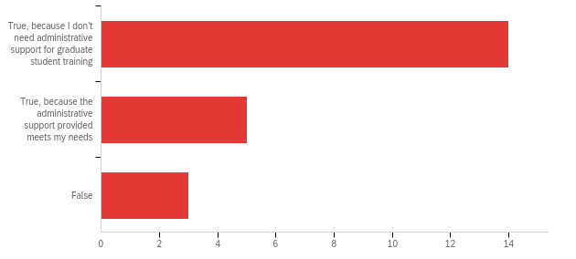

|  |  |  |  |  |  |  |  |
| --- | --- | --- | --- | --- | --- | --- | --- |
| # | Field | Minimum | Maximum | Mean | Std Deviation | Variance | Count |
| 1 | My Department or School/College adequately meets my administrative support needs for UC graduate student training. | 1.00 | 3.00 | 1.50 | 0.72 | 0.52 | 22 |

|  |  |  |  |
| --- | --- | --- | --- |
| # | Answer | % | Count |
| 1 | True, because I don’t need administrative support for graduate student training | 63.64% | 14 |
| 2 | True, because the administrative support provided meets my needs | 22.73% | 5 |
| 3 | False | 13.64% | 3 |
|  | Total | 100% | 22 |

**Q39 - My Department or School/College adequately meets my administrative support needs for UC undergraduate student teaching.**

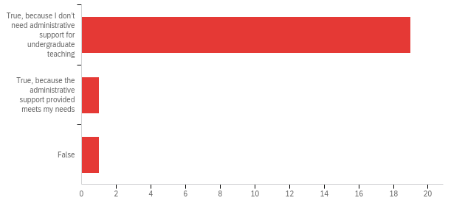

|  |  |  |  |  |  |  |  |
| --- | --- | --- | --- | --- | --- | --- | --- |
| # | Field | Minimum | Maximum | Mean | Std Deviation | Variance | Count |
| 1 | My Department or School/College adequately meets my administrative support needs for UC undergraduate student teaching. | 1.00 | 3.00 | 1.14 | 0.47 | 0.22 | 21 |

|  |  |  |  |
| --- | --- | --- | --- |
| # | Answer | % | Count |
| 1 | True, because I don’t need administrative support for undergraduate teaching | 90.48% | 19 |
| 2 | True, because the administrative support provided meets my needs | 4.76% | 1 |
| 3 | False | 4.76% | 1 |
|  | Total | 100% | 21 |

**Q40 - My Department or School/College adequately meets my administrative support needs for University-related travel.**

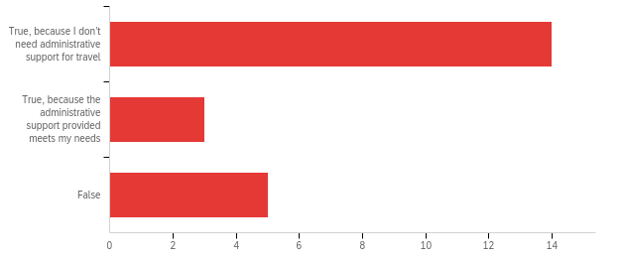

|  |  |  |  |  |  |  |  |
| --- | --- | --- | --- | --- | --- | --- | --- |
| # | Field | Minimum | Maximum | Mean | Std Deviation | Variance | Count |
| 1 | My Department or School/College adequately meets my administrative support needs for University-related travel. | 1.00 | 3.00 | 1.59 | 0.83 | 0.70 | 22 |

|  |  |  |  |
| --- | --- | --- | --- |
| # | Answer | % | Count |
| 1 | True, because I don’t need administrative support for travel | 63.64% | 14 |
| 2 | True, because the administrative support provided meets my needs | 13.64% | 3 |
| 3 | False | 22.73% | 5 |
|  | Total | 100% | 22 |

**Q41 - My School or College has a well-defined organizational approach to Emeriti relations.**

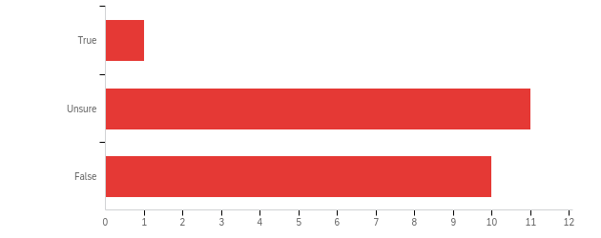

|  |  |  |  |  |  |  |  |
| --- | --- | --- | --- | --- | --- | --- | --- |
| # | Field | Minimum | Maximum | Mean | Std Deviation | Variance | Count |
| 1 | My School or College has a well-defined organizational approach to Emeriti relations. | 1.00 | 3.00 | 2.41 | 0.58 | 0.33 | 22 |

|  |  |  |  |
| --- | --- | --- | --- |
| # | Answer | % | Count |
| 1 | True | 4.55% | 1 |
| 2 | Unsure | 50.00% | 11 |
| 3 | False | 45.45% | 10 |
|  | Total | 100% | 22 |

**Q42 - If you answered "True", please list the activities organized specifically for Emeriti.**

If you answered "True", please list the activities organized specifically for Emeriti.

**Q43 - My Department, School/College organizes activities specifically for Emeriti.**

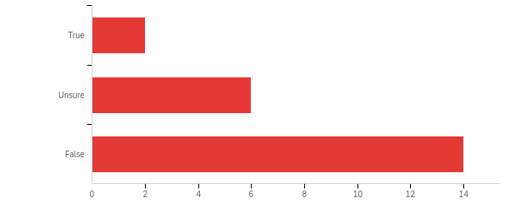

|  |  |  |  |  |  |  |  |
| --- | --- | --- | --- | --- | --- | --- | --- |
| # | Field | Minimum | Maximum | Mean | Std Deviation | Variance | Count |
| 1 | My Department, School/College organizes activities specifically for Emeriti. | 1.00 | 3.00 | 2.55 | 0.66 | 0.43 | 22 |

|  |  |  |  |
| --- | --- | --- | --- |
| # | Answer | % | Count |
| 1 | True | 9.09% | 2 |
| 2 | Unsure | 27.27% | 6 |
| 3 | False | 63.64% | 14 |
|  | Total | 100% | 22 |

**Q45 - In your School or College, which of the following do you believe are the main points of contact with Emeriti? Please rank your choices by dragging the options to the top or bottom.**

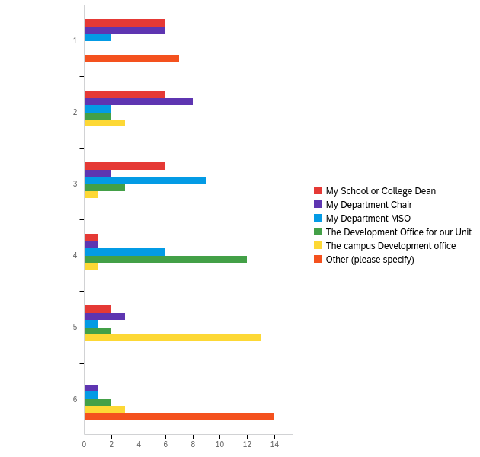

|  |  |  |  |  |  |  |  |
| --- | --- | --- | --- | --- | --- | --- | --- |
| # | Field | Minimum | Maximum | Mean | Std Deviation | Variance | Count |
| 1 | My School or College Dean | 1.00 | 5.00 | 2.38 | 1.21 | 1.47 | 21 |
| 2 | My Department Chair | 1.00 | 6.00 | 2.52 | 1.53 | 2.34 | 21 |
| 3 | My Department MSO | 1.00 | 6.00 | 3.24 | 1.15 | 1.32 | 21 |
| 4 | The Development Office for our Unit | 2.00 | 6.00 | 3.95 | 1.00 | 1.00 | 21 |
| 5 | The campus Development office | 2.00 | 6.00 | 4.57 | 1.22 | 1.48 | 21 |
| 6 | Other (please specify) | 1.00 | 6.00 | 4.33 | 2.36 | 5.56 | 21 |

|  |  |  |  |  |  |  |  |  |  |  |  |  |  |  |
| --- | --- | --- | --- | --- | --- | --- | --- | --- | --- | --- | --- | --- | --- | --- |
| # | Question | 1 |  | 2 |  | 3 |  | 4 |  | 5 |  | 6 |  | Total |
| 1 | My School or College Dean | 28.57% | 6 | 28.57% | 6 | 28.57% | 6 | 4.76% | 1 | 9.52% | 2 | 0.00% | 0 | 21 |
| 2 | My Department Chair | 28.57% | 6 | 38.10% | 8 | 9.52% | 2 | 4.76% | 1 | 14.29% | 3 | 4.76% | 1 | 21 |
| 3 | My Department MSO | 9.52% | 2 | 9.52% | 2 | 42.86% | 9 | 28.57% | 6 | 4.76% | 1 | 4.76% | 1 | 21 |
| 4 | The Development Office for our Unit | 0.00% | 0 | 9.52% | 2 | 14.29% | 3 | 57.14% | 12 | 9.52% | 2 | 9.52% | 2 | 21 |
| 5 | The campus Development office | 0.00% | 0 | 14.29% | 3 | 4.76% | 1 | 4.76% | 1 | 61.90% | 13 | 14.29% | 3 | 21 |
| 6 | Other (please specify) | 33.33% | 7 | 0.00% | 0 | 0.00% | 0 | 0.00% | 0 | 0.00% | 0 | 66.67% | 14 | 21 |

**Q46 - Based on your experience leading up to retirement and in retirement, are there services, programs, resources or activities that you would like to see your Department, School/College or Campus offer? In other words, what more could the University do for you?**

|  |
| --- |
| Based on your experience leading up to retirement and in retirement, are there services, programs, resources or activities that you would like to see your Department, School/College or Campus offer? In other words, what more could the University do for you? |
| IT has been a mess. Still working through some of it. |
| advice regarding the optimal time for retirement based on your employment record |
| Have some kind of actual program for emeriti that don't involve the former department/division |
| Can't think of any. |
| n/a |
| Nothing Needed at this Time |
| I could easily assist with faculty mentoring and career development but there is no interest in this |
| medical school attentions towards emeriti will be very uneven |
| More hand-holding and guidance in the paperwork process which is confusing! |
| the UCRAYS was a poor experience with little personal contact or help. It was a low point in the retirement process. |
| University support fine, departmental support absent |

**Q47 - Would you object to receiving a brief follow-up written or electronic survey that is more specific to your Department, School or College?**

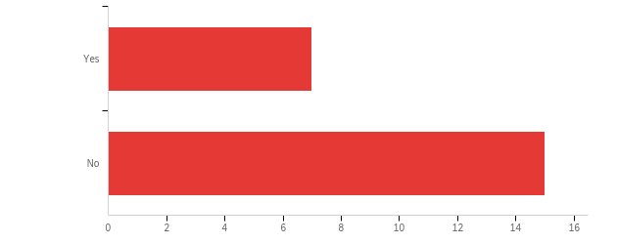

|  |  |  |  |  |  |  |  |
| --- | --- | --- | --- | --- | --- | --- | --- |
| # | Field | Minimum | Maximum | Mean | Std Deviation | Variance | Count |
| 1 | Would you object to receiving a brief follow-up written or electronic survey that is more specific to your Department, School or College? | 1.00 | 2.00 | 1.68 | 0.47 | 0.22 | 22 |

|  |  |  |  |
| --- | --- | --- | --- |
| # | Answer | % | Count |
| 1 | Yes | 31.82% | 7 |
| 2 | No | 68.18% | 15 |
|  | Total | 100% | 22 |

**Q48 - Would you like someone from your Department, School/College or Campus to reach out to you to follow up on issues and ideas you raised in your survey responses?**

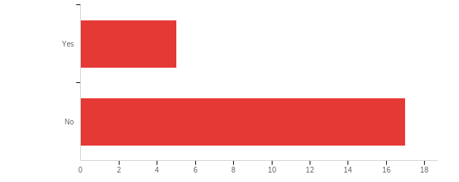

|  |  |  |  |  |  |  |  |
| --- | --- | --- | --- | --- | --- | --- | --- |
| # | Field | Minimum | Maximum | Mean | Std Deviation | Variance | Count |
| 1 | Would you like someone from your Department, School/College or Campus to reach out to you to follow up on issues and ideas you raised in your survey responses? | 1.00 | 2.00 | 1.77 | 0.42 | 0.18 | 22 |

|  |  |  |  |
| --- | --- | --- | --- |
| # | Answer | % | Count |
| 1 | Yes | 22.73% | 5 |
| 2 | No | 77.27% | 17 |
|  | Total | 100% | 22 |

**Q50 - Are you a member of the UC Davis Emeriti Association (UCDEA)?**

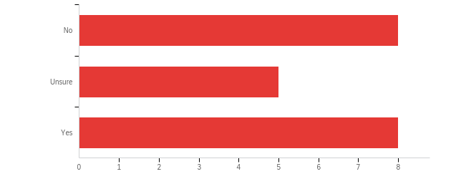

|  |  |  |  |  |  |  |  |
| --- | --- | --- | --- | --- | --- | --- | --- |
| # | Field | Minimum | Maximum | Mean | Std Deviation | Variance | Count |
| 1 | Are you a member of the UC Davis Emeriti Association (UCDEA)? | 1.00 | 3.00 | 2.00 | 0.87 | 0.76 | 21 |

|  |  |  |  |
| --- | --- | --- | --- |
| # | Answer | % | Count |
| 1 | No | 38.10% | 8 |
| 2 | Unsure | 23.81% | 5 |
| 3 | Yes | 38.10% | 8 |
|  | Total | 100% | 21 |

**Q51 - If you are a UCDEA member, what in your opinion are the most important programs, services, resources or activities provided by the UCDEA? Please rank your choices by dragging the options to the top or bottom.**

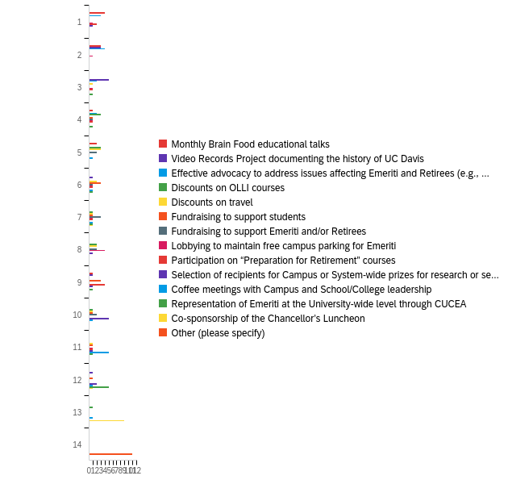

|  |  |  |  |  |  |  |  |
| --- | --- | --- | --- | --- | --- | --- | --- |
| # | Field | Minimum | Maximum | Mean | Std Deviation | Variance | Count |
| 1 | Monthly Brain Food educational talks | 1.00 | 9.00 | 3.00 | 2.41 | 5.82 | 11 |
| 2 | Video Records Project documenting the history of UC Davis | 2.00 | 12.00 | 4.36 | 3.14 | 9.87 | 11 |
| 3 | Effective advocacy to address issues affecting Emeriti and Retirees (e.g., Health Benefits) | 1.00 | 4.00 | 2.27 | 1.05 | 1.11 | 11 |
| 4 | Discounts on OLLI courses | 4.00 | 13.00 | 6.64 | 2.77 | 7.69 | 11 |
| 5 | Discounts on travel | 3.00 | 11.00 | 6.73 | 2.26 | 5.11 | 11 |
| 6 | Fundraising to support students | 4.00 | 12.00 | 8.09 | 2.35 | 5.54 | 11 |
| 7 | Fundraising to support Emeriti and/or Retirees | 4.00 | 10.00 | 7.00 | 1.86 | 3.45 | 11 |
| 8 | Lobbying to maintain free campus parking for Emeriti | 1.00 | 11.00 | 6.00 | 2.95 | 8.73 | 11 |
| 9 | Participation on “Preparation for Retirement” courses | 1.00 | 11.00 | 6.27 | 3.36 | 11.29 | 11 |
| 10 | Selection of recipients for Campus or System-wide prizes for research or service | 1.00 | 12.00 | 9.36 | 2.87 | 8.23 | 11 |
| 11 | Coffee meetings with Campus and School/College leadership | 5.00 | 13.00 | 9.82 | 2.48 | 6.15 | 11 |
| 12 | Representation of Emeriti at the University-wide level through CUCEA | 3.00 | 12.00 | 9.09 | 3.34 | 11.17 | 11 |
| 13 | Co-sponsorship of the Chancellor’s Luncheon | 7.00 | 13.00 | 12.36 | 1.72 | 2.96 | 11 |
| 14 | Other (please specify) | 14.00 | 14.00 | 14.00 | 0.00 | 0.00 | 11 |

|  |  |  |  |  |  |  |  |  |  |  |  |  |  |  |  |  |  |  |  |  |  |  |  |  |  |  |  |  |  |  |
| --- | --- | --- | --- | --- | --- | --- | --- | --- | --- | --- | --- | --- | --- | --- | --- | --- | --- | --- | --- | --- | --- | --- | --- | --- | --- | --- | --- | --- | --- | --- |
| # | Question | 1 |  | 2 |  | 3 |  | 4 |  | 5 |  | 6 |  | 7 |  | 8 |  | 9 |  | 10 |  | 11 |  | 12 |  | 13 |  | 14 |  | Total |
| 1 | Monthly Brain Food educational talks | 36.36% | 4 | 27.27% | 3 | 0.00% | 0 | 9.09% | 1 | 18.18% | 2 | 0.00% | 0 | 0.00% | 0 | 0.00% | 0 | 9.09% | 1 | 0.00% | 0 | 0.00% | 0 | 0.00% | 0 | 0.00% | 0 | 0.00% | 0 | 11 |
| 2 | Video Records Project documenting the history of UC Davis | 0.00% | 0 | 27.27% | 3 | 45.45% | 5 | 0.00% | 0 | 0.00% | 0 | 9.09% | 1 | 0.00% | 0 | 0.00% | 0 | 9.09% | 1 | 0.00% | 0 | 0.00% | 0 | 9.09% | 1 | 0.00% | 0 | 0.00% | 0 | 11 |
| 3 | Effective advocacy to address issues affecting Emeriti and Retirees (e.g., Health Benefits) | 27.27% | 3 | 36.36% | 4 | 18.18% | 2 | 18.18% | 2 | 0.00% | 0 | 0.00% | 0 | 0.00% | 0 | 0.00% | 0 | 0.00% | 0 | 0.00% | 0 | 0.00% | 0 | 0.00% | 0 | 0.00% | 0 | 0.00% | 0 | 11 |
| 4 | Discounts on OLLI courses | 0.00% | 0 | 0.00% | 0 | 0.00% | 0 | 27.27% | 3 | 27.27% | 3 | 0.00% | 0 | 9.09% | 1 | 18.18% | 2 | 0.00% | 0 | 9.09% | 1 | 0.00% | 0 | 0.00% | 0 | 9.09% | 1 | 0.00% | 0 | 11 |
| 5 | Discounts on travel | 0.00% | 0 | 0.00% | 0 | 9.09% | 1 | 0.00% | 0 | 27.27% | 3 | 18.18% | 2 | 9.09% | 1 | 18.18% | 2 | 0.00% | 0 | 9.09% | 1 | 9.09% | 1 | 0.00% | 0 | 0.00% | 0 | 0.00% | 0 | 11 |
| 6 | Fundraising to support students | 0.00% | 0 | 0.00% | 0 | 0.00% | 0 | 9.09% | 1 | 0.00% | 0 | 27.27% | 3 | 9.09% | 1 | 0.00% | 0 | 27.27% | 3 | 9.09% | 1 | 9.09% | 1 | 9.09% | 1 | 0.00% | 0 | 0.00% | 0 | 11 |
| 7 | Fundraising to support Emeriti and/or Retirees | 0.00% | 0 | 0.00% | 0 | 0.00% | 0 | 9.09% | 1 | 18.18% | 2 | 9.09% | 1 | 27.27% | 3 | 18.18% | 2 | 0.00% | 0 | 18.18% | 2 | 0.00% | 0 | 0.00% | 0 | 0.00% | 0 | 0.00% | 0 | 11 |
| 8 | Lobbying to maintain free campus parking for Emeriti | 9.09% | 1 | 9.09% | 1 | 9.09% | 1 | 9.09% | 1 | 0.00% | 0 | 9.09% | 1 | 9.09% | 1 | 36.36% | 4 | 0.00% | 0 | 0.00% | 0 | 9.09% | 1 | 0.00% | 0 | 0.00% | 0 | 0.00% | 0 | 11 |
| 9 | Participation on “Preparation for Retirement” courses | 18.18% | 2 | 0.00% | 0 | 9.09% | 1 | 9.09% | 1 | 0.00% | 0 | 9.09% | 1 | 9.09% | 1 | 0.00% | 0 | 36.36% | 4 | 0.00% | 0 | 9.09% | 1 | 0.00% | 0 | 0.00% | 0 | 0.00% | 0 | 11 |
| 10 | Selection of recipients for Campus or System-wide prizes for research or service | 9.09% | 1 | 0.00% | 0 | 0.00% | 0 | 0.00% | 0 | 0.00% | 0 | 0.00% | 0 | 0.00% | 0 | 9.09% | 1 | 9.09% | 1 | 45.45% | 5 | 9.09% | 1 | 18.18% | 2 | 0.00% | 0 | 0.00% | 0 | 11 |
| 11 | Coffee meetings with Campus and School/College leadership | 0.00% | 0 | 0.00% | 0 | 0.00% | 0 | 0.00% | 0 | 9.09% | 1 | 9.09% | 1 | 9.09% | 1 | 0.00% | 0 | 0.00% | 0 | 9.09% | 1 | 45.45% | 5 | 9.09% | 1 | 9.09% | 1 | 0.00% | 0 | 11 |
| 12 | Representation of Emeriti at the University-wide level through CUCEA | 0.00% | 0 | 0.00% | 0 | 9.09% | 1 | 9.09% | 1 | 0.00% | 0 | 9.09% | 1 | 9.09% | 1 | 0.00% | 0 | 9.09% | 1 | 0.00% | 0 | 9.09% | 1 | 45.45% | 5 | 0.00% | 0 | 0.00% | 0 | 11 |
| 13 | Co-sponsorship of the Chancellor’s Luncheon | 0.00% | 0 | 0.00% | 0 | 0.00% | 0 | 0.00% | 0 | 0.00% | 0 | 0.00% | 0 | 9.09% | 1 | 0.00% | 0 | 0.00% | 0 | 0.00% | 0 | 0.00% | 0 | 9.09% | 1 | 81.82% | 9 | 0.00% | 0 | 11 |
| 14 | Other (please specify) | 0.00% | 0 | 0.00% | 0 | 0.00% | 0 | 0.00% | 0 | 0.00% | 0 | 0.00% | 0 | 0.00% | 0 | 0.00% | 0 | 0.00% | 0 | 0.00% | 0 | 0.00% | 0 | 0.00% | 0 | 0.00% | 0 | 100.00% | 11 | 11 |

**Q52 - Have you completed an interview for the Video Records Project, which documents the history of UC Davis and the contribution of Emeriti, individually and collectively?**

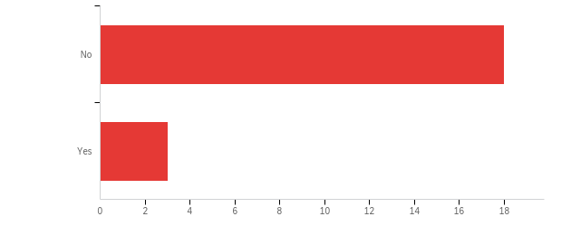

|  |  |  |  |  |  |  |  |
| --- | --- | --- | --- | --- | --- | --- | --- |
| # | Field | Minimum | Maximum | Mean | Std Deviation | Variance | Count |
| 1 | Have you completed an interview for the Video Records Project, which documents the history of UC Davis and the contribution of Emeriti, individually and collectively? | 1.00 | 2.00 | 1.14 | 0.35 | 0.12 | 21 |

|  |  |  |  |
| --- | --- | --- | --- |
| # | Answer | % | Count |
| 1 | No | 85.71% | 18 |
| 2 | Yes | 14.29% | 3 |
|  | Total | 100% | 21 |

**Q55 - How often do you attend the monthly UCDEA Brain Food talks, either in person or by Zoom?**

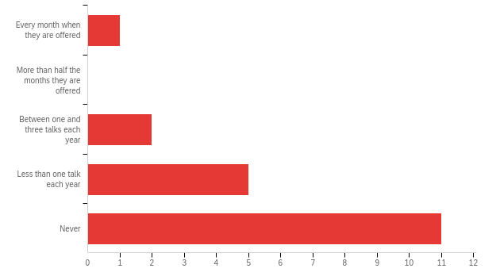

|  |  |  |  |  |  |  |  |
| --- | --- | --- | --- | --- | --- | --- | --- |
| # | Field | Minimum | Maximum | Mean | Std Deviation | Variance | Count |
| 1 | How often do you attend the monthly UCDEA Brain Food talks, either in person or by Zoom? | 1.00 | 5.00 | 4.32 | 1.03 | 1.06 | 19 |

|  |  |  |  |
| --- | --- | --- | --- |
| # | Answer | % | Count |
| 1 | Every month when they are offered | 5.26% | 1 |
| 2 | More than half the months they are offered | 0.00% | 0 |
| 3 | Between one and three talks each year | 10.53% | 2 |
| 4 | Less than one talk each year | 26.32% | 5 |
| 5 | Never | 57.89% | 11 |
|  | Total | 100% | 19 |

**Q56 - If a School/College-specific UCDEA Chapter was formed to represent the Emeriti in your School/College, would you be interested in participating?**

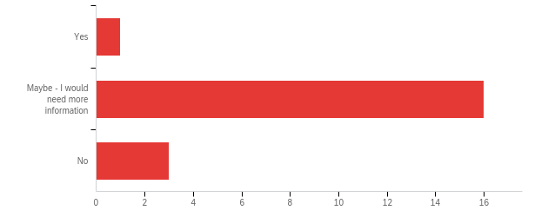

|  |  |  |  |  |  |  |  |
| --- | --- | --- | --- | --- | --- | --- | --- |
| # | Field | Minimum | Maximum | Mean | Std Deviation | Variance | Count |
| 1 | If a School/College-specific UCDEA Chapter was formed to represent the Emeriti in your School/College, would you be interested in participating? | 1.00 | 3.00 | 2.10 | 0.44 | 0.19 | 20 |

|  |  |  |  |
| --- | --- | --- | --- |
| # | Answer | % | Count |
| 1 | Yes | 5.00% | 1 |
| 2 | Maybe - I would need more information | 80.00% | 16 |
| 3 | No | 15.00% | 3 |
|  | Total | 100% | 20 |

**Q57 - Should the governance structure of the UCDEA include at least one emeritus faculty member from each School/College on the UCD campus; for example, as a member of a UCDEA Committee?**

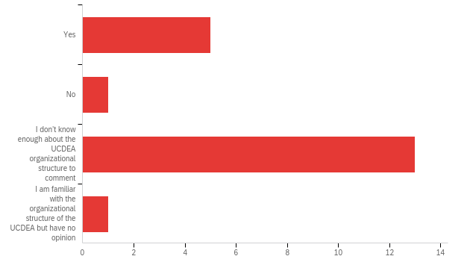

|  |  |  |  |  |  |  |  |
| --- | --- | --- | --- | --- | --- | --- | --- |
| # | Field | Minimum | Maximum | Mean | Std Deviation | Variance | Count |
| 1 | Should the governance structure of the UCDEA include at least one emeritus faculty member from each School/College on the UCD campus; for example, as a member of a UCDEA Committee? | 1.00 | 4.00 | 2.50 | 0.92 | 0.85 | 20 |

|  |  |  |  |
| --- | --- | --- | --- |
| # | Answer | % | Count |
| 1 | Yes | 25.00% | 5 |
| 2 | No | 5.00% | 1 |
| 3 | I don’t know enough about the UCDEA organizational structure to comment | 65.00% | 13 |
| 4 | I am familiar with the organizational structure of the UCDEA but have no opinion | 5.00% | 1 |
|  | Total | 100% | 20 |

**Q58 - If you are not a member of the UCDEA, what is/are the main reason(s) for not joining the organization? Please check all that apply.**

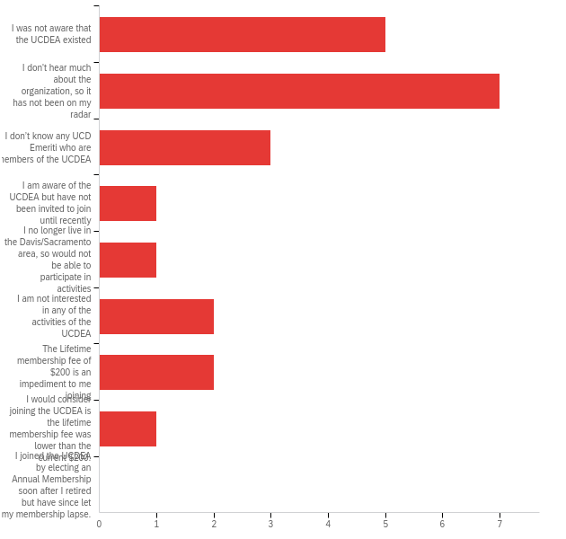

|  |  |  |  |
| --- | --- | --- | --- |
| # | Answer | % | Count |
| 1 | I was not aware that the UCDEA existed | 22.73% | 5 |
| 2 | I don't hear much about the organization, so it has not been on my radar | 31.82% | 7 |
| 3 | I don’t know any UCD Emeriti who are members of the UCDEA | 13.64% | 3 |
| 4 | I am aware of the UCDEA but have not been invited to join until recently | 4.55% | 1 |
| 5 | I no longer live in the Davis/Sacramento area, so would not be able to participate in activities | 4.55% | 1 |
| 6 | I am not interested in any of the activities of the UCDEA | 9.09% | 2 |
| 7 | The Lifetime membership fee of $200 is an impediment to me joining | 9.09% | 2 |
| 8 | I would consider joining the UCDEA is the lifetime membership fee was lower than the current $200. | 4.55% | 1 |
| 9 | I joined the UCDEA by electing an Annual Membership soon after I retired but have since let my membership lapse. | 0.00% | 0 |
|  | Total | 100% | 22 |

**Q59 - Were you aware of the study performed last year by the Council of University of California Emeriti Associations (CUCEA) concluding that the output/contributions of Emeriti across all ten UC campuses was equivalent to the output of one whole campus?**

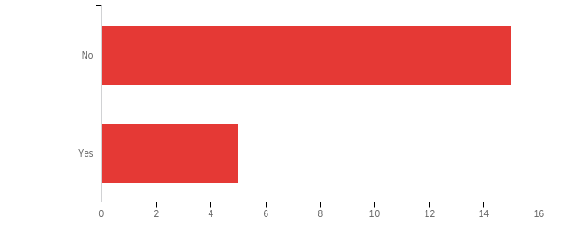

|  |  |  |  |  |  |  |  |
| --- | --- | --- | --- | --- | --- | --- | --- |
| # | Field | Minimum | Maximum | Mean | Std Deviation | Variance | Count |
| 1 | Were you aware of the study performed last year by the Council of University of California Emeriti Associations (CUCEA) concluding that the output/contributions of Emeriti across all ten UC campuses was equivalent to the output of one whole campus? | 1.00 | 2.00 | 1.25 | 0.43 | 0.19 | 20 |

|  |  |  |  |
| --- | --- | --- | --- |
| # | Answer | % | Count |
| 1 | No | 75.00% | 15 |
| 2 | Yes | 25.00% | 5 |
|  | Total | 100% | 20 |

**Q60 - Would you like someone from the UCDEA to contact you to provide more information about the association or to hear your suggestions regarding new programs or initiatives?**

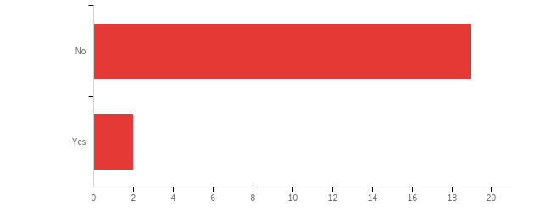

|  |  |  |  |  |  |  |  |
| --- | --- | --- | --- | --- | --- | --- | --- |
| # | Field | Minimum | Maximum | Mean | Std Deviation | Variance | Count |
| 1 | Would you like someone from the UCDEA to contact you to provide more information about the association or to hear your suggestions regarding new programs or initiatives? | 1.00 | 2.00 | 1.10 | 0.29 | 0.09 | 21 |

|  |  |  |  |
| --- | --- | --- | --- |
| # | Answer | % | Count |
| 1 | No | 90.48% | 19 |
| 2 | Yes | 9.52% | 2 |
|  | Total | 100% | 21 |

**Q62 - Based on your experience leading up to retirement and in retirement, are there services, programs, resources or activities that you would like to see the UCDEA offer? In other words, what more could the UCDEA do for you?**

|  |
| --- |
| Based on your experience leading up to retirement and in retirement, are there services, programs, resources or activities that you would like to see the UCDEA offer? In other words, what more could the UCDEA do for you? |
| It might be good for those planning to retire to be able to speak with a member to discuss issues |
| I continue to work full time, so many of the activities I cannot attend. Would prefer Sacramento based activities. |
| I can't think of anything. |
| n/a |
| No Need |
| aid to spouses of diseased faculty members is of considerable importance |
| i don't have an opinion |
| Earlier outreach and mentorship program |

**Q_StraightliningCount**

|  |  |  |  |  |  |  |  |
| --- | --- | --- | --- | --- | --- | --- | --- |
| # | Field | Minimum | Maximum | Mean | Std Deviation | Variance | Count |
| 1 | Q_StraightliningCount | 0.00 | 0.00 | 0.00 | 0.00 | 0.00 | 23 |

**Q_StraightliningPercentage**

|  |  |  |  |  |  |  |  |
| --- | --- | --- | --- | --- | --- | --- | --- |
| # | Field | Minimum | Maximum | Mean | Std Deviation | Variance | Count |
| 1 | Q_StraightliningPercentage | 0.00 | 0.00 | 0.00 | 0.00 | 0.00 | 23 |

**Q_StraightliningQuestions**



|  |  |  |
| --- | --- | --- |
| Answer | % | Count |
| Total |  | undefined |